NAVAL SUPPORT ACTIVITY
MONTEREY
CORRESPONDENCE ROUTE SLIP
SUBJ: Subject

N-CODE | IN | DATE  OUT | INITIALS |  | DATE: | ROUTING NO.
 |  |  | CONCUR | NON-CONCUR OR COMMENTS
CO
 |  |  |  |  | FROM:
Deputy
SEL |  |  |  |  | TO:
EA |  |  |  |  | RETURN TO:
AO
DH/N#
XXX |  |  |  |  | DATE ACTION REQUIRED:
XXX
XXX
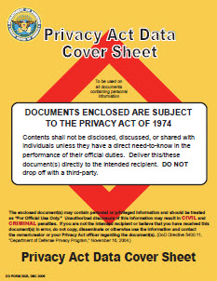
Comments:

Use PII version ONLY if the folder contains PII (otherwise, use standard routing sheet)

Include offices in the routing chain prior to DH/N-Code as needed

Admin will enter the routing number

Send softcopy editable Word document to Admin Asst and AO for editing / re-printing

Include supporting documents in left pocket of folder (excerpts from Instructions, letters, etc)

Provide justification for anything requested “ASAP” “Expedite” or action required within less than 5 business days

